UNIT 6 HW

1. 



µ1, µ2, µ3, µ4, and µ5, are the mean scores in the none, amputee, crutches, hearing, and wheelchair groups respectively. Be careful when identifying ‘k’ here.

1. 



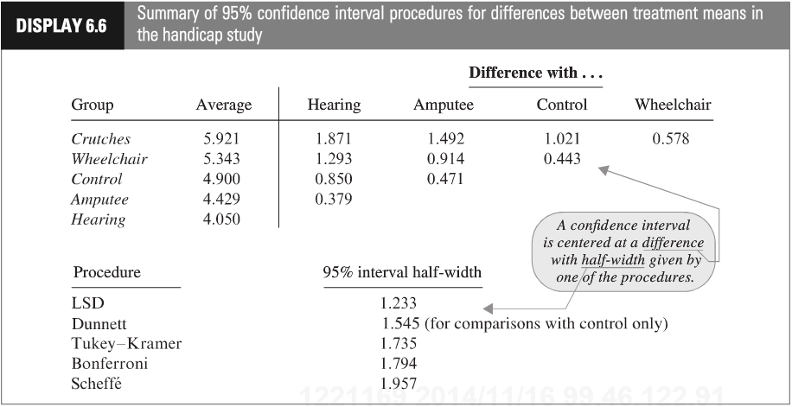

Show your work for this problem by simply copying the code and relevant output for each comparison. (Cut and paste your code and relevant output.) The half-width might be found directly from your output. If so, note where it is found. Do this for both R and SAS.

1. 

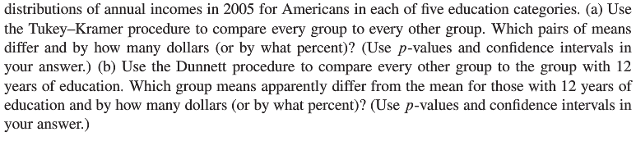

This question is obviously from the book, but assume you are starting this problem from scratch. Show all parts:

(1) Discussion of Assumptions (This could result in the inferences no longer being about the means. IF that happens, you should still compare the groups, just use the appropriate parameters when making inferences. Remember that you already did the work for addressing assumptions in prior homeworks.)

(2) Selection and Execution of Tests

(3) Interpretation and Conclusion.

In short, perform a complete analysis like you usually do. Provide and interpret all the confidence intervals that suggest a significant difference in incomes; provide your SAS and R code as well. (Generate your statistics using both softwares.)

**Finally, you should first test to see if any of the groups are different before you consider pairwise comparisons.**

Bonus: Max 5 pts



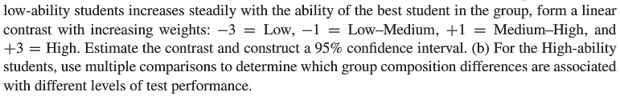

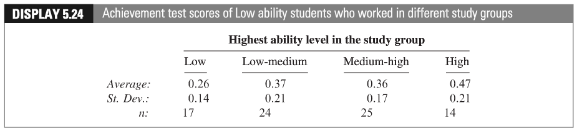

(c) Give the levels of ability a quantitative representation (Low = 1, Low-Medium = 2, etc.) for the low ability students. After completing the questions above, conduct a linear regression (we haven’t studied this yet!) of the **AVERAGE** performance against the level variable you just created. Be sure and address the assumptions. Defend the ones you can and assume the others are met. Include a scatterplot and residual plot. Is there evidence of linear trend? Is this inferred from the contrast? Assume the levels are equidistant in ability from each other.

Note: the data for Part b above is in Display 5.25 in your textbook.